# **Kyle Buckley Video Transcript**

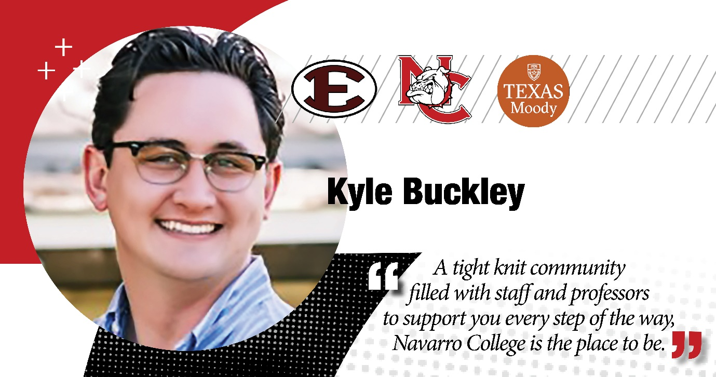

**Kyle Buckley:** My name is Kyle Buckley.

I was a Navarro College graduate of 2015 where I was able to, thankfully receive multiple different scholarships from the Navarro College organization, as well as really get involved in the community both at the Waxahachie and Corsicana campuses.

Um, I cannot think enough the time and the memories that I made with both the student recruiting staff that I worked alongside with, as well as the academic advisors at the Waxahachie campus who helped me each semester with creating schedules for myself and ensuring that I was set up for success.

Um, and lastly, obviously, the the former president, Doctor Martin, who was able to be a huge support center for myself during my time at the Waxahachie campus.

Um, after my graduation from Navarro College, I was able to transfer to the University of Texas at Austin, where I was able to take my academics and extend them and receive my bachelor’s in communications in year 2017.

Um, today, I serve as a Software Sales Executive here in the greater Austin area in Georgetown, Texas. And I cannot recommend enough Navarro College to any new students who are seeking not only a place to kick start their academic career and develop as a professional, but also if you're looking to seek a tight knit community filled with staff and professors that will be there to support you every step of the way, Navarro College is the place to be.