# **Samantha Stalcup Video Transcript**

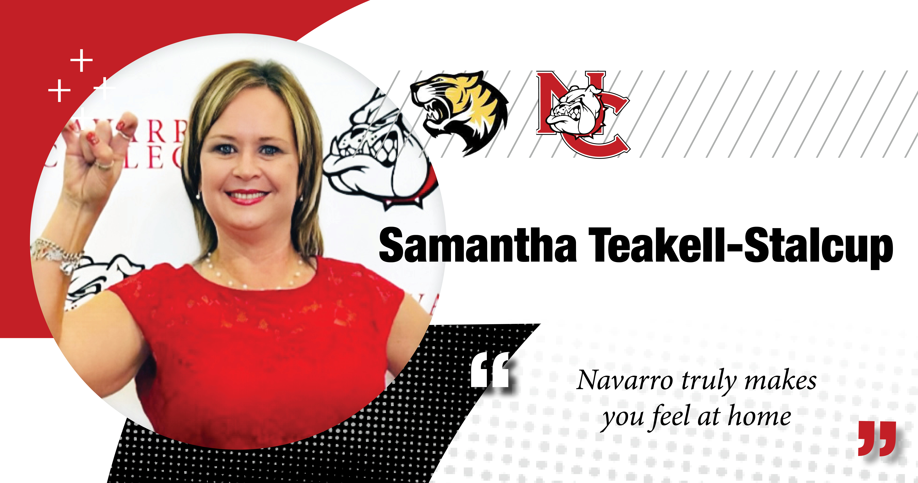

**Samantha Stalcup**: Hi, my name is Samantha Stalcup. I had just graduated with my CCMA and I am currently working with Visiting Angels Home Healthcare in Cedar Hill, Texas.

I was currently working at Army Air Force for 14 years as Accounting Tech lead.

I decided that was not my passion. My passion was to help people.

I decided to enroll back in Navarro College in 2019, um, to pursue my career in nursing.

I went ahead and got my CNA then pursued to CCMA, and I'm currently working with Visiting Angels Home Health Care Center and uh, Cedar Hill, Texas.

I also work with Lenity Light Hospice in Watauga, Texas. I’m a PRN. I am currently working towards my bachelor’s in nursing at Navarro College at this time.