# **Terri Mitchell Video Transcript**

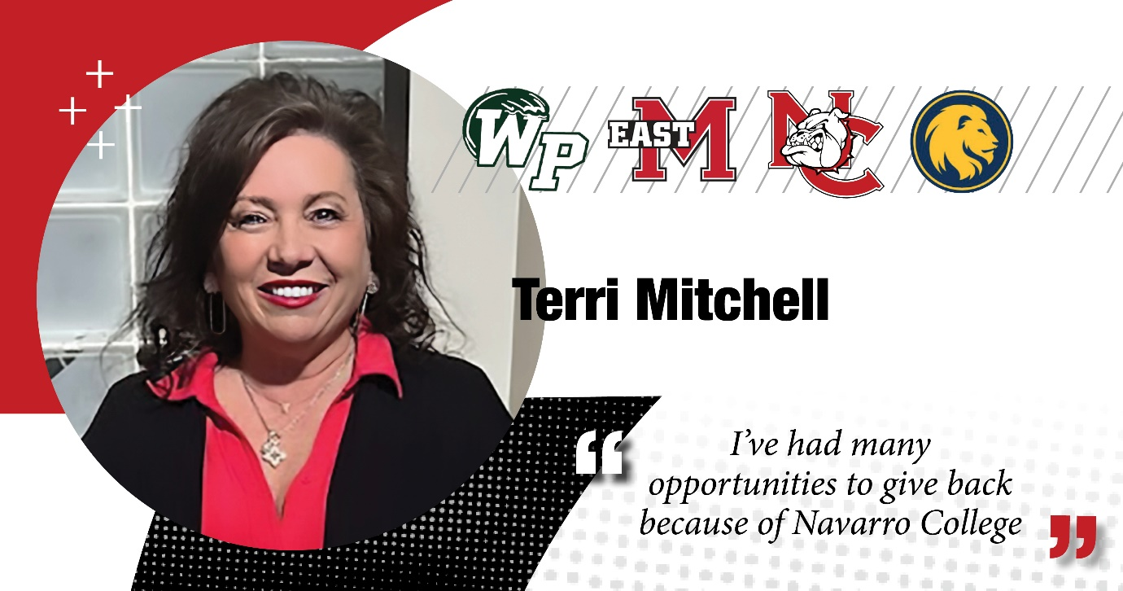

**Terri Mitchell:** Hi, my name is Terry Mitchell and I'm the Director of College Stores for Navarro College.

And I have to tell you my journey did not begin as director. It began as a student and a mother of six who was looking for an opportunity to complete my degree in business management.

And when I discovered Navarro College and found out about the partnership that we had with A&M Commerce, that was the answer to my prayers.

So I was able to take classes at Navarro and continue on with my education to transfer over to Texas A&M Commerce, where I did achieve that degree that I had hoped for so many years.

I also decided that I wanted to be able to give back, and my life kind of came full circle. You know, I helped a lot of students when I worked at Bealls continue their education through Navarro College, and many of those also went to the partnership with A&M Commerce.

So after that, I was recruited to come work for Navarro College, which really was exciting for me and I did join the team in 2014.

So this is my 10th here at Navarro College as an employee, but my journey here has been a journey of 30 years.

And I love, love, love the opportunity to be able to give back and to help others, which is why I continue to work on the Dancing for Our Stars committee and try to always look for opportunities for affordable books and opportunities for students to get scholarships that they need.